EECS 700 Project 2

-Manjish Adhikari , 2870257

SWITCH AND MAC OPERATION

The switch to led operation was performed correctly by mapping to the proper Io register at 0xC0000000 and similary mac operation for d=a\*b+c was performed by using the proper registers.

Given

A=1+2j b=2+0j c=2+0j so d was calculated as 4+4j

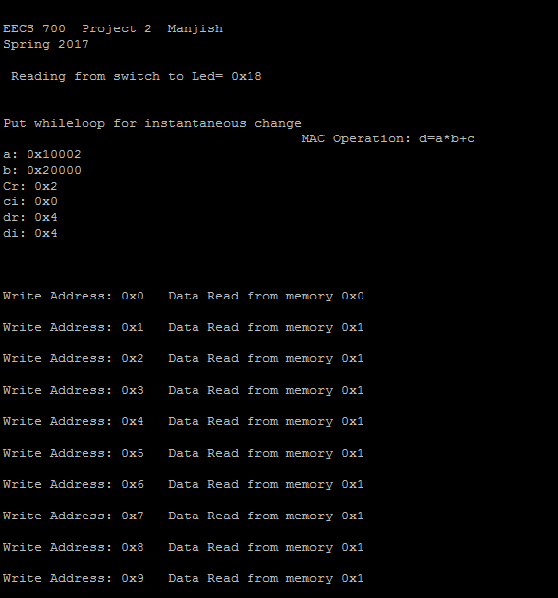

DFT CALCULATION

In the calculation of DFT since everything is fixed point operations however the twiddle factors were floating point so they were converted into fixed point by using a factor and was again removed by division with the factor so this might have caused a little error in the dft calculations.

For eg for twiddle factor w(1)=0.98-0.195j was changed to 10-2j for performing the multiplication and and was later removed.

Here memory was written from the C-code and value of sequence of 32 1’s were sent as 1 1 1 1 1….

After DFT the value should be 32 0 0……

So the first result was calculated properly because twiddle factor is 1 however other twiddle factors were approximated to fixed points so instead of 0, it was approximated to ‘1’ so the result was obtained as 32 1 1 1 1 1 1 …….

